SCHOOL NAME

Accessing Workflows

Use the following information to connect to Host. This configuration needs to be completed once, will then remain as is for further logins on the computer.

1. Enter IP address: _____________________________

2. Enter Port number ______________

3. Check “Show this window on next startup.”

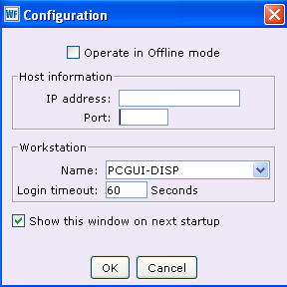

1

2

3

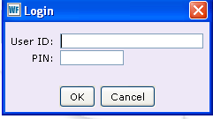
- Enter your User ID.
4
______________________________
5
- Enter your PIN.

______________________________

